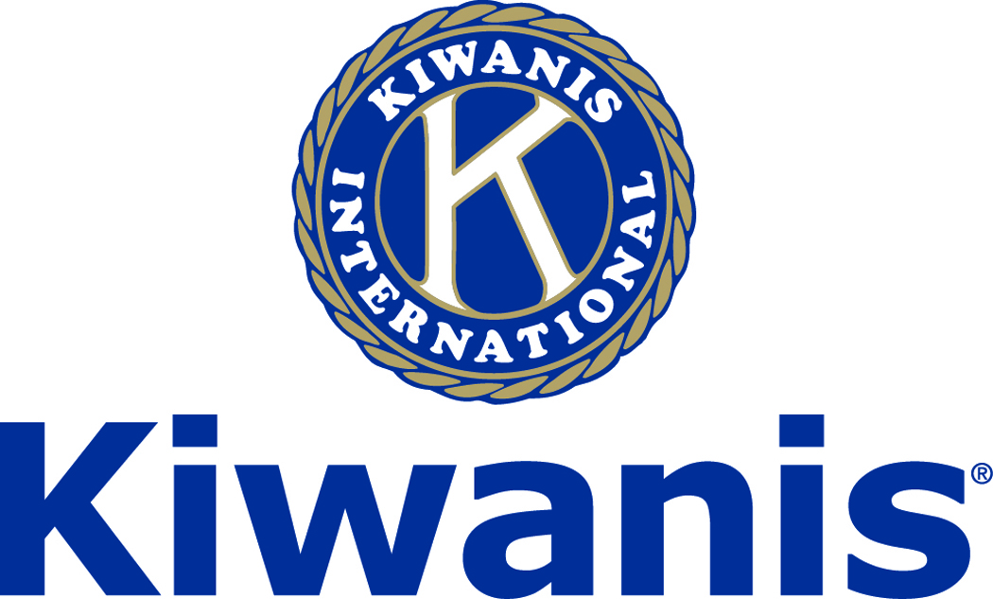
Club of Las Vegas
Week of:
March 4, 2018

http://www.kiwaniscluboflasvegas.org/

******************************************************************
RSVP now for:
Varsity Quiz Awards Luncheon
Wednesday, March 14,

(note special time and price)
~ RSVP’s only Seating is limited ~
Lunch $25 cash or check only
Networking: 11:00am. Meeting: 11:30am
You will have three choices for lunch.
Make your choice BEFORE you arrive,
and tell Tara when you enter the room.

Lunch choices:
1. Callender's Cheeseburger - and French Fries.
2. Chicken Tenders with BBQ or Ranch sauce and French Fries.
3. Fettuccini Alfredo & Caesar Salad.
If you have a diet restriction, let Tara know.

Anticipated guests: the CCSD Superintendent, the Director of Student Activities, the CCSD VQ Coordinator, Moderator Nate Tannenbaum, the VQ Coach of the Year, the coaches of the Blue and Silver winning teams, some VQ students, and the winner of the Howard W. Naylor Varsity Quiz Scholarship.

******************************************************************

SPEAKER for March 7th MEETING:

Scott Stevens, LTCOL, USAF (Ret.)
All about drones.

Networking: 11:45am. Meeting: 12:15 to 1:15pm.

Wednesday’s, Marie Callender's, 8175 West Sahara,
Lunch ($20) and includes a slice of pie.

******************************************************************

Win a free lunch!
Read this newsletter for details

******************************************************************

Donate to the
Kiwanis Club of Las Vegas Foundation
a 501(c)(3) charitable organization

Help us fund our programs with your tax deductible donation to our Kiwanis Club of Las Vegas Foundation

******************************************************************
Watch Varsity Quiz Monday’s at 7:30PM on TV Channel 10.

******************************************************************

Please Use Amazon-Smile
Select Kiwanis Club of Las Vegas Foundation as your charity when making your purchases.

When you order at Amazon-Smile, Amazon donates to
Kiwanis Club of Las Vegas Foundation
This year we’ve received $157.57

Use smile.amazon.com and Amazon will donate to Kiwanis Club of Las Vegas Foundation. Sign up with Amazon Smile and designate the Kiwanis Club of Las Vegas Foundation as your charity. Amazon will donate 0.5% of the price of your eligible Amazon Smile purchases to Kiwanis Club of Las Vegas Foundation whenever you shop on Amazon Smile. Amazon Smile is the same Amazon you know. Same products, Same prices, Same service. Use the link below and you will be directed to great gift ideas and help support your Kiwanis Club of Las Vegas Foundation.
AmazonSmile click here: smile.amazon.com/ch/86-0850741

******************************************************************

Varsity Quiz

Playoff games are now being broadcast on Channel 10 on Mondays at 7:30PM. The next playoff game will be Monday February 19th at 7:30PM on Channel 10 for the Blue League championship. The Silver League semi final competition will begin on February 26th. The Silver League high school teams competing will be: Coronado HS, Meadows HS, Clark HS, Las Vegas Academy HS, Green Valley HS, Palo Verde HS, Arbor View HS, and Liberty HS. This is the 49th season of Varsity Quiz. The Varsity Quiz Program is patterned after a high school program that was being sponsored by the Kiwanis Club of Greater Anaheim. In 1969 a delegation from that club convinced the leadership of the Kiwanis Club of Las Vegas to sponsor a similar program in Clark County. The Southern Nevada program was named Varsity Quiz. It is conducted within the Clark County School District (CCSD). The Varsity Quiz Program is a partnership between the Kiwanis Club of Las Vegas, CCSD, and Vegas PBS TV-10.

******************************************************************

Varsity Quiz Question of the Week

Do you know the answer to this question?

Most of the lake named for Gamal Abdel Nasser lies in what country?

(the answer will be in your next newsletter)

Answer to last week’s Question

T. S. Eliot wrote “Old Possum’s Book of Practical ________?

“Cats”

******************************************************************
Service Hours
Be sure to turn in your service hours to Nancy Sapling

Fill out the form at our weekly lunches or
Email your service hours to Nancy at: Nancy.Sapling7@gmail.com

******************************************************************

UPCOMING March 2018 EVENTS

March 7: - Scott Stevens, LTCOL, USAF (Ret.) - all about drones

March 14: - VQ Awards Lunch

March 21: - Patrick Ballinger - the Boy Scouts in Southern Nevada

March 28:: - Jim Marsh of Jim Marsh Kia

*******************************************************************

FREE LUNCH!

Each week we hold a random drawing
and one of our members wins a free lunch, including a slice of pie, redeemable at one of our next three regular meetings.

Congratulations’
>>>> Kevin Page <<<<
You won a FREE Lunch

Redeem your free lunch at one of our next three meetings
March 7th, or 21st or 28th meeting!

*******************************************************************

Save your POP-TABS to benefit
Ronald Mc Donald House

If you have pop tabs to donate contact Len Yelinek.

******************************************************************

For club information Log onto our Web Site!

You can make a donation to our club on our web home page.

http://www.kiwaniscluboflasvegas.org/

contact Jerry McElroy or Howard Naylor
with additions or corrections

*******************************************************************

