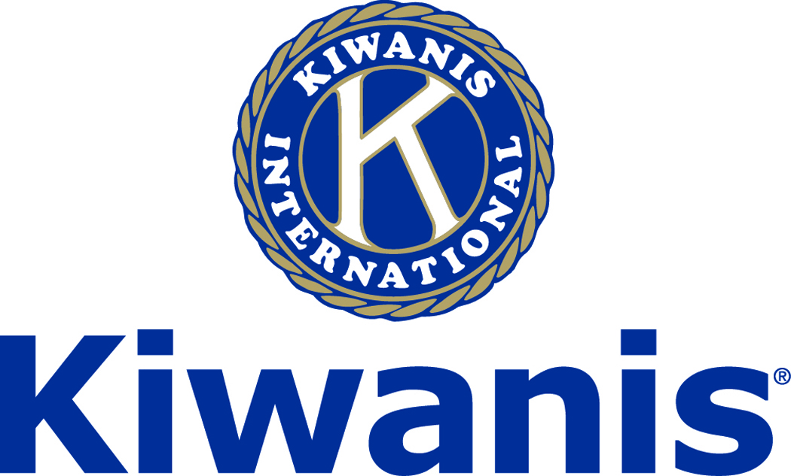
Club of Las Vegas
Week of:
July 2, 2017
http://www.kiwaniscluboflasvegas.org/

******************************************************************

Plan to attend:
Division 28 DCM.
. Saturday, July 8th at 10:00AM . .
hosted by:
The Kiwanis Club of Pahrump Valley

Meeting location:
The Valley Electric Conference Center,
800 E. Highway 372, Pahrump, NV.

This is our opportunity to inter club with Pahrump.

******************************************************************

E-Mail Silent Auction
Winning bid will be announced
at this week’s meeting

******************************************************************
Win a free lunch!
Read this newsletter for details

******************************************************************

SPEAKER for July 5 MEETING:
John Case:
John will bring details regarding
the Minneapolis Bridge failure.

Networking: 11:45am. Meeting: 12:15 to 1:15pm.

Wednesday’s, Marie Callender's, 8175 West Sahara,
Lunch ($20) and includes a slice of pie.

******************************************************************

E-Mail Silent Auction

The Kiwanis Club of Las Vegas
Is auctioning $100 in gift cards for

Classic steakhouse in a wood-decked space
featuring live piano music, moody lighting & a bar
Galleria Mall
1300 W Sunset Rd
Henderson Nevada

This $100 in gift cards will be awarded to the person making largest donation to the Kiwanis Club of Las Vegas Foundation

Winning bid will be announced
This Wednesday July 5, 2017

To see an up-to-date high-bid go to:
http://www.kiwaniscluboflasvegas.org/

Current bid $100
Reply NOW to this e-mail with your bid!

This is a Donation to the Kiwanis Club of Las Vegas Foundation

Tickets donated by a member of Kiwanis Club of Las Vegas

THE STORY OF LARSEN’S STEAKS
Larsen’s requires a highly skilled butcher to be at the location at all times to monitor airflow, temperature, and humidity. During dry aging, the prime meats’ natural enzymes act as soothing tenderizers. At the same time, moisture evaporation improves the supple texture and hearty taste of the meat, making it richer and more buttery. Dry aging continues until a thin coating develops on the meat surface. This coating seals in flavor and juice, and is later trimmed off. Larsen’s then wet ages its beef for another arduous fourteen days, preserving its flavor of highly marbled, prime grade meat, from exceptional cattle breed. This process is a respected, time-honored technique of preparing high quality beef. It ensures that our guests enjoy the best steak they’ve ever had.
Furthermore, our diligent method of preparation includes slowly searing the meat in its own natural juices at 500 degrees, rather than blast cooking it at 1700 degrees like most steakeries. Why rush your steak? We cook it slower, making it the best steak possible. No exceptions.
******************************************************************

You Can Make a Tax Free Donation to the
Kiwanis Club of Las Vegas Foundation

The IRA Charitable Rollover is now permanent, allowing individuals aged 70 ½ or older to make a tax-free distribution from individual retirement accounts to the Kiwanis Club of Las Vegas Foundation, reducing their tax liability!

The Protecting Americans from Tax Hikes Act of 2015 has been signed into law. Among the many tax benefits made permanent was the IRA charitable transfer provision.

This provision allows individuals age 70½ or older to give up to $100,000 from their IRAs directly to qualified charities - such as the Kiwanis Club of Las Vegas Foundation - without having to pay income taxes on the distributions and the donations count as part of the IRA owner's RMD required annual withdrawal.

There's no tax deduction for the donated assets; however, they are not included as income, either. To qualify for this break, the donation must be transferred directly from the IRA custodian to the Foundation and gifts for 2016 must be made by the year-end.

Contact your financial advisor to find out how you may benefit from this new law.

******************************************************************

FREE LUNCH!

Each week we hold a random drawing
and one of our members wins a free lunch, including a slice of pie, redeemable at one of our next three regular meetings.

Congratulations’
>>>> Erica Nansen <<<<
You won a FREE Lunch

Redeem your free lunch at one of our next three meetings
July 5, 12 or 19 meeting!
See you there!

******************************************************************

Use Amazon-Smile for your purchases.

When you do Amazon donates to
Kiwanis Club of Las Vegas Foundation

Please Use smile.amazon.com and Amazon will donate to Kiwanis Club of Las Vegas Foundation. Sign up with Amazon Smile and designate the Kiwanis Club of Las Vegas Foundation as your charity. Amazon will donate 0.5% of the price of your eligible Amazon Smile purchases to Kiwanis Club of Las Vegas Foundation whenever you shop on Amazon Smile. Amazon Smile is the same Amazon you know. Same products, Same prices, Same service. Use the link below and you will be directed to great gift ideas and help support your Kiwanis Club of Las Vegas Foundation.
AmazonSmile click here: smile.amazon.com/ch/86-0850741

*******************************************************************
Service Hours
Be sure to turn in your service hours to Nancy Sapling
Fill out the form at our weekly lunches or
Email your service hours to Nancy at: Nancy.Sapling7@gmail.com

******************************************************************

Donate to the
Kiwanis Club of Las Vegas Foundation

Help us fund our programs with your tax deductible donation to our Kiwanis Club of Las Vegas Foundation

******************************************************************

UPCOMING July 2017 EVENTS:

July 5: - John Case will bring details regarding the Minneapolis Bridge failure

July 12: - Allyce Pierson on the programs of the Special Olympics in Las Vegas

July 19: - Ryan Swint represents Brighton Hospice of Nevada

July 26: - We will hear of the RTC's future Transit plan for Southern Nevada

*******************************************************************

For club information Log onto our Web Site!
http://www.kiwaniscluboflasvegas.org/

contact Jerry McElroy or Howard Naylor
with additions or corrections

*******************************************************************

