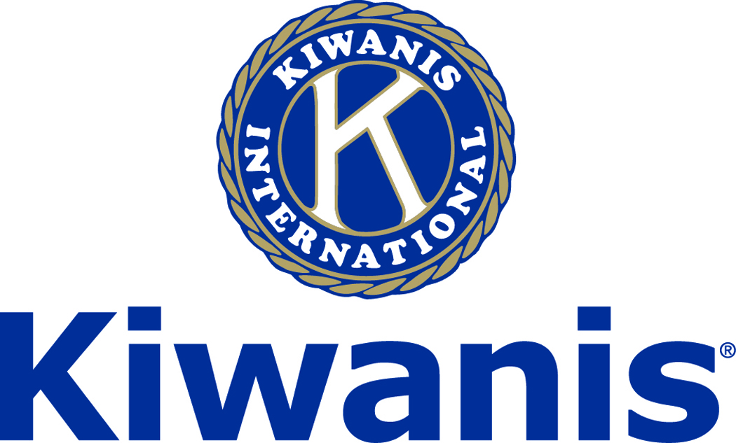
Club of Las Vegas
Week of:
February 4, 2018

http://www.kiwaniscluboflasvegas.org/

******************************************************************
Watch Varsity Quiz every Monday at 7:30PM on PBS TV Channel 10

******************************************************************

SPEAKER for February 7th MEETING:

Alan Snel
Alan will speak about the dynamic sports market of Las Vegas and the news site, www.LVSportsBiz.com. This is a boutique niche news website. The goal is to break news and scoops; publish analysis and trend stories; and do good journalism. They are not a blog. They don't cover sports games. They cover the business, politics and social/cultural issues that shape the games. There website is not a lot of razzle-dazzle but it is attractive and well organized.

Networking: 11:45am. Meeting: 12:15 to 1:15pm.

Wednesday’s, Marie Callender's, 8175 West Sahara,
Lunch ($20) and includes a slice of pie.

******************************************************************
Varsity Quiz

Playoff games are now being broadcast on Channel 10 on Mondays at 7:30PM. The first playoff game will be Monday February 5th at 7:30PM on Channel 10 and will feature Moapa Valley HS vs. Las Vegas HS. Then on February 12th at 7:30pm it will be Faith Lutheran HS vs. Bishop Gorman HS. The winners of the February 5th and 12th matches will compete on February 19th for the Blue League championship. The Silver League semi final competition will begin on February 26th. The Silver League high school teams competing will be: Coronado HS, Meadows HS, Clark HS, Las Vegas Academy HS, Green Valley HS, Palo Verde HS, Arbor View HS, and Liberty HS. This is the 49th season of Varsity Quiz. The Varsity Quiz Program is patterned after a high school program that was being sponsored by the Kiwanis Club of Greater Anaheim. In 1969 a delegation from that club convinced the leadership of the Kiwanis Club of Las Vegas to sponsor a similar program in Clark County. The Southern Nevada program was named Varsity Quiz. It is conducted within the Clark County School District (CCSD). The Varsity Quiz Program is a partnership between the Kiwanis Club of Las Vegas, CCSD, and Vegas PBS TV-10.

******************************************************************

Win a free lunch!
Read this newsletter for details

******************************************************************

Donate to the
Kiwanis Club of Las Vegas Foundation
a 501(c)(3) charitable organization

Help us fund our programs with your tax deductible donation to our Kiwanis Club of Las Vegas Foundation

******************************************************************

Please Use Amazon-Smile
Select Kiwanis Club of Las Vegas Foundation as your charity when making your purchases.

When you order at Amazon-Smile, Amazon donates to
Kiwanis Club of Las Vegas Foundation
This year we’ve received $157.57

Use smile.amazon.com and Amazon will donate to Kiwanis Club of Las Vegas Foundation. Sign up with Amazon Smile and designate the Kiwanis Club of Las Vegas Foundation as your charity. Amazon will donate 0.5% of the price of your eligible Amazon Smile purchases to Kiwanis Club of Las Vegas Foundation whenever you shop on Amazon Smile. Amazon Smile is the same Amazon you know. Same products, Same prices, Same service. Use the link below and you will be directed to great gift ideas and help support your Kiwanis Club of Las Vegas Foundation.
AmazonSmile click here: smile.amazon.com/ch/86-0850741

******************************************************************

Varsity Quiz Question of the Week

Do you know the answer to this question?

The word “moa” and “kiwi” came into English from what language of the indigenous people of New Zealand?

(the answer will be in your next newsletter)

Answer to last week’s Question

In Goethe’s poem, “The Sorcerer’s Apprentice” what household tool does the young boy enchant to fetch water in a pail?

“Broom”

******************************************************************
Service Hours
Be sure to turn in your service hours to Nancy Sapling

Fill out the form at our weekly lunches or
Email your service hours to Nancy at: Nancy.Sapling7@gmail.com

******************************************************************

UPCOMING February 2018 EVENTS

February 7: - Alan Snel, The dynamic sports market of Las Vegas

February 14: - Laura Alvarado, United Blood Service, Have a heart

February 21: - Darrelynn Bonstell - How to be a Savvy Senior

February 28: - Stephanie Gerken, What is a Service Dog?

*******************************************************************

FREE LUNCH!

Each week we hold a random drawing
and one of our members wins a free lunch, including a slice of pie, redeemable at one of our next three regular meetings.

Congratulations’
>>>> Ilya Rockwell <<<<
You won a FREE Lunch

Redeem your free lunch at one of our next three meetings
Jan. 31st, Feb. 7th or 14th meeting!

*******************************************************************

Save your POP-TABS to benefit
Ronald Mc Donald House

If you have pop tabs to donate contact Len Yelinek.

******************************************************************

For club information Log onto our Web Site!

You can make a donation to our club on our web home page.

http://www.kiwaniscluboflasvegas.org/

contact Jerry McElroy or Howard Naylor
with additions or corrections

*******************************************************************

