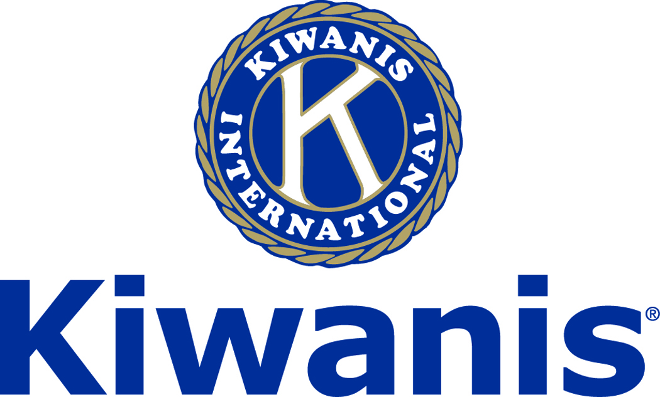
Club of Las Vegas

Week of:
April 29, 2018

http://www.kiwaniscluboflasvegas.org/

******************************************************************
Don’t miss your
Kiwanis Club of Las Vegas
Annual Meeting May 9th
. .

This is our 2018-2019 Annual Elections
Contact Phil Colosimo for information
about how you can help.

******************************************************************

SPEAKER for May 2nd MEETING:

Jan Hogan
former RJ News writer and author

Networking: 11:45am. Meeting: 12:15 to 1:15pm.

Wednesday’s, Marie Callender's, 8175 West Sahara,
Lunch ($20) and includes a slice of pie.

******************************************************************
Coming Soon
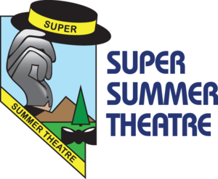

Kiwanis Club of Las Vegas
SUPER SUMMER THEATER
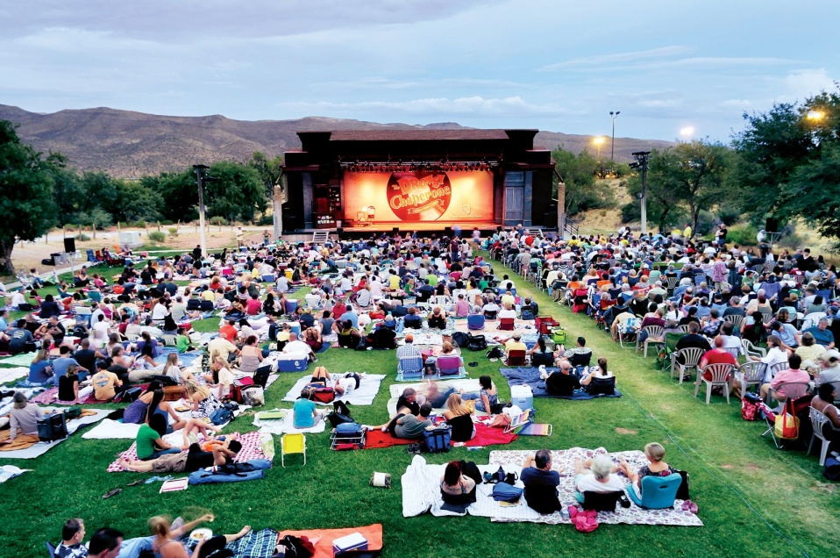

******************************************************************

You’re invited to:
The Kiwanis Club of the Strip
Friday May 4, 2018 7am
Speaker
Elizabeth Helgelien,
candidate for State Senate District 8,
See Howard Naylor for more information

******************************************************************

Varsity Quiz

Playoff games are now being broadcast on Channel 10 on Mondays at 7:30PM. This is the 49th season of Varsity Quiz. The Varsity Quiz Program is patterned after a high school program that was being sponsored by the Kiwanis Club of Greater Anaheim. In 1969 a delegation from that club convinced the leadership of the Kiwanis Club of Las Vegas to sponsor a similar program in Clark County. The Southern Nevada program was named Varsity Quiz. It is conducted within the Clark County School District (CCSD). The Varsity Quiz Program is a partnership between the Kiwanis Club of Las Vegas, CCSD, and Vegas PBS TV-10.

******************************************************************

Win a free lunch!
Read this newsletter for details

******************************************************************

Donate to the
Kiwanis Club of Las Vegas Foundation
a 501(c)(3) charitable organization

Help us fund our programs with your tax deductible donation to our Kiwanis Club of Las Vegas Foundation

******************************************************************

Save your POP-TABS to benefit
Ronald Mc Donald House

If you have pop tabs to donate contact Len Yelinek.

******************************************************************

Please Use Amazon-Smile
Select Kiwanis Club of Las Vegas Foundation as your charity when making your purchases.

When you order at Amazon-Smile, Amazon donates to
Kiwanis Club of Las Vegas Foundation
This year we’ve received $170.52

Use smile.amazon.com and Amazon will donate to Kiwanis Club of Las Vegas Foundation. Sign up with Amazon Smile and designate the Kiwanis Club of Las Vegas Foundation as your charity. Amazon will donate 0.5% of the price of your eligible Amazon Smile purchases to Kiwanis Club of Las Vegas Foundation whenever you shop on Amazon Smile. Amazon Smile is the same Amazon you know. Same products, Same prices, Same service. Use the link below and you will be directed to great gift ideas and help support your Kiwanis Club of Las Vegas Foundation.
AmazonSmile click here: smile.amazon.com/ch/86-0850741

******************************************************************

FREE LUNCH!

Each week we hold a random drawing
and one of our members wins a free lunch, including a slice of pie, redeemable at one of our next three regular meetings.

Congratulations’
>>>> RoBert Sidell <<<<
You won a FREE Lunch

Redeem your free lunch at one of our next three meetings
May 2nd, 9th, or 16th meeting!

*******************************************************************

Service Hours
Be sure to turn in your service hours to Nancy Sapling

Fill out the form at our weekly lunches or
Email your service hours to Nancy at: Nancy.Sapling7@gmail.com

******************************************************************

UPCOMING May 2018 EVENTS

May 2: - Jan Hogan, former RJ News writer and author
May 9: - Luke Schimp, General Manager, Coolairnow, all things A/C
May 16: - Tammi Williams, Director Food and Beverage Safety, MGM Resorts
May 23: - John Case - An important bridge failure
May 30: - Kobbe Shaw - Tortoises, both captive and wild

*******************************************************************

For club information Log onto our Web Site!

You can make a donation to our club on our web home page.

http://www.kiwaniscluboflasvegas.org/

contact Jerry McElroy or Howard Naylor
with additions or corrections

******************************************************************

