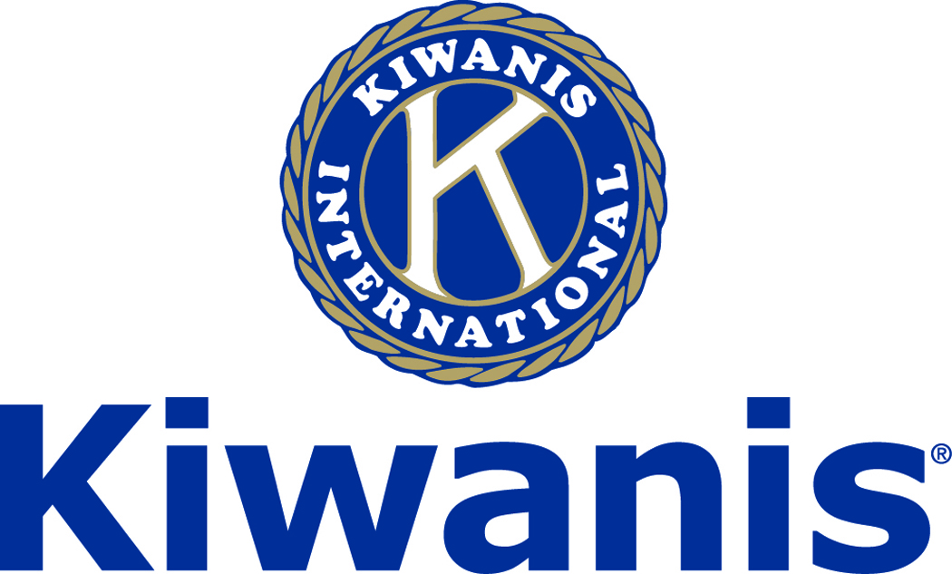
Club of Las Vegas

Week of:
June 4, 2017

http://www.kiwaniscluboflasvegas.org/

******************************************************************

Win a free lunch!
Read this newsletter for details

******************************************************************

SPEAKER for June 7 MEETING:
Mason VanHouweling:

Mason is the CEO of University Medical Center

Networking: 11:45am. Meeting: 12:15 to 1:15pm.

Wednesday’s, Marie Callender's, 8175 West Sahara,
Lunch ($20) and includes a slice of pie.

******************************************************************

SPEAKER for June 14 MEETING:
Paul Joncich:

Paul Joncich, News Anchor, TV Channel 8

******************************************************************

LAST WEEK!
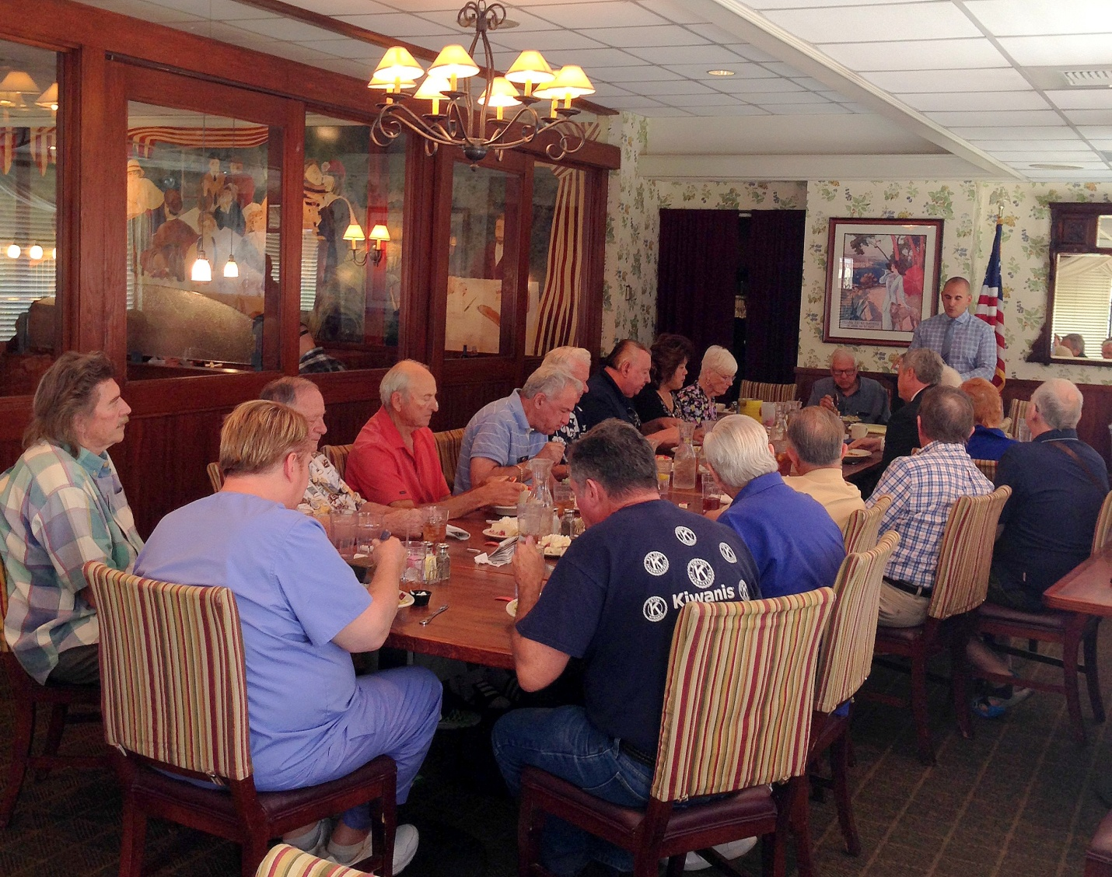
Billy Hemberger spoke to a full house:

Billy, from Spring Valley High School,
is our 2017 Educator of the year award winner!

******************************************************************

Sign up now for Masters Golf Fundraiser

Our Club will make money and it will NOT cost you anything, other than a few minutes of your time
Please help!

******************************************************************

Kiwanis Club of Las Vegas
SUPER SUMMER THEATER
June 17th

TICKETS ON SALE NOW.
Ticket cost: $15.00
Everyone is responsible to buy their own tickets.

Purchase tickets in person at the following locations:
1. Prestige Travel, 7550 W. Lake Mead, Suite 7, Las Vegas, NV 89128 (NE Corner)
2. Super Summer Theatre Studios, 4340 S. Valley View, Las Vegas, NV 89103 (Valley View and Flamingo)

We expect this will be a “sell out”. There may be limited tickets at the gate for $20.00.
Pot luck will start at 6:30 p.m. (Meadow opens at 6:00 p.m.) Chairs for $1.00

Go to the Super Summer Theatre website for more information.

Are you ready to go back to 1985?
Get out your Swatch watches and silver sequined glove! The musical version of The Wedding Singer (based on the hit Adam Sandler movie) is gonna build this city on Rock-n-Roll!
The time is 1985 and rock-star wannabe Robbie Hart is New Jersey's favorite wedding singer. He's the life of the party, until his fiancée Linda leaves him at the altar. Shot through the heart, Robbie has hit rock bottom. Enter Julia, a winsome waitress who wins his affection. As luck, would have it, Julia daydreams about marrying Glen, a Wall Street shark; and unless Robbie can pull off the performance of the decade, the girl of his dreams will be gone forever.
With a totally rad score accompanied by a LIVE BAND, The Wedding Singer will make you wish you were back in the time when MTV played videos, Rubik’s Cubes were all the rage, and you’d never be caught without your acid washed jeans!

Sign up at our weekly meeting or contact Nancy Sapling (e-mail) nancy.sapling7@gmail.com. Pot luck will start at 6:30 p.m. (Meadow opens at 6:00 p.m.) Chairs for $1.00. Out usual crew will get an "early in" pass and get the shelter house set up for the potluck and get the chairs set up in the meadow.

Members can also go to the Super Summer Theatre website and check out all of this information.

******************************************************************

Use Amazon-Smile for your purchases.

When you do Amazon donates to
Kiwanis Club of Las Vegas Foundation

Please Use smile.amazon.com and Amazon will donate to Kiwanis Club of Las Vegas Foundation. Sign up with Amazon Smile and designate the Kiwanis Club of Las Vegas Foundation as your charity. Amazon will donate 0.5% of the price of your eligible Amazon Smile purchases to Kiwanis Club of Las Vegas Foundation whenever you shop on Amazon Smile. Amazon Smile is the same Amazon you know. Same products, Same prices, Same service. Use the link below and you will be directed to great gift ideas and help support your Kiwanis Club of Las Vegas Foundation.
AmazonSmile click here: smile.amazon.com/ch/86-0850741

*******************************************************************

Service Hours
Be sure to turn in your service hours to Nancy Sapling
Fill out the form at our weekly lunches or
Email Nancy at: Nancy.Sapling7@gmail.com

******************************************************************

FREE LUNCH!

Each week we hold a random drawing
and one of our members wins a free lunch, including a slice of pie, redeemable at one of our next three regular meetings.

Congratulations’
>>>> Lee Ziegler <<<<
You won a FREE Lunch

Redeem your free lunch at one of our next three meetings
June 7, 14, or 21 meeting!
See you there!

******************************************************************

Donate to the
Kiwanis Club of Las Vegas Foundation

Help us fund our programs with your tax deductible donation to our Kiwanis Club of Las Vegas Foundation

******************************************************************

You Can Make a Tax Free Donation to the
Kiwanis Club of Las Vegas Foundation

The IRA Charitable Rollover is now permanent, allowing individuals aged 70 ½ or older to make a tax-free distribution from individual retirement accounts to the Kiwanis Club of Las Vegas Foundation, reducing their tax liability!

The Protecting Americans from Tax Hikes Act of 2015 has been signed into law. Among the many tax benefits made permanent was the IRA charitable transfer provision.

This provision allows individuals age 70½ or older to give up to $100,000 from their IRAs directly to qualified charities - such as the Kiwanis Club of Las Vegas Foundation - without having to pay income taxes on the distributions and the donations count as part of the IRA owner's RMD required annual withdrawal.

There's no tax deduction for the donated assets; however, they are not included as income, either. To qualify for this break, the donation must be transferred directly from the IRA custodian to the Foundation and gifts for 2016 must be made by the year-end.

Contact your financial advisor to find out how you may benefit from this new law.

******************************************************************

UPCOMING June 2017 EVENTS:

June 7: - Mason VanHouweling, CEO University Medical Center

June 14: - Paul Joncich, News Anchor, TV Channel 8

June 21: - Steph Lowrey, Sales and Marketing Director for Revel Nevada, a new Active Senior Living choice

June 28: - Jennifer Lewis, Public Information Officer for the Nevada State Contractors Board

*******************************************************************

For club information Log onto our Web Site!
http://www.kiwaniscluboflasvegas.org/

contact Jerry McElroy or Howard Naylor
with additions or corrections

*******************************************************************

