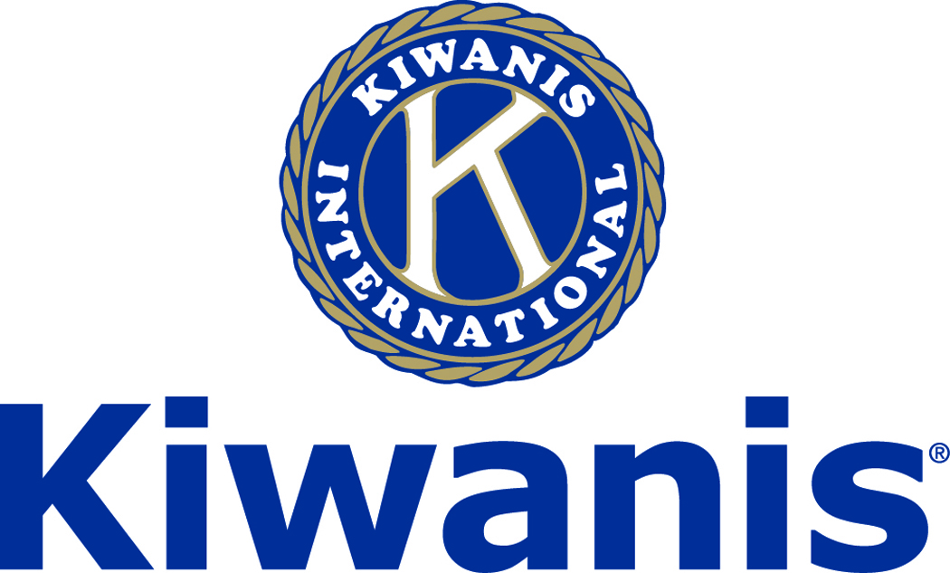
Club of Las Vegas
Week of:
January 1, 2018

http://www.kiwaniscluboflasvegas.org/

******************************************************************

SPEAKER for January 3rd MEETING:

Brian Hoeft,
Director of the RTC Traffic Management Center.

Networking: 11:45am. Meeting: 12:15 to 1:15pm.

Wednesday’s, Marie Callender's, 8175 West Sahara,
Lunch ($20) and includes a slice of pie.

******************************************************************

Win a free lunch!
Read this newsletter for details

******************************************************************
Please Use Amazon-Smile
Select Kiwanis Club of Las Vegas Foundation as your charity when making your purchases.

When you order at Amazon-Smile, Amazon donates to
Kiwanis Club of Las Vegas Foundation
This year we’ve received $157.57

Use smile.amazon.com and Amazon will donate to Kiwanis Club of Las Vegas Foundation. Sign up with Amazon Smile and designate the Kiwanis Club of Las Vegas Foundation as your charity. Amazon will donate 0.5% of the price of your eligible Amazon Smile purchases to Kiwanis Club of Las Vegas Foundation whenever you shop on Amazon Smile. Amazon Smile is the same Amazon you know. Same products, Same prices, Same service. Use the link below and you will be directed to great gift ideas and help support your Kiwanis Club of Las Vegas Foundation.
AmazonSmile click here: smile.amazon.com/ch/86-0850741

******************************************************************

Varsity Quiz Question of the Week

Do you know the answer to this question?

What kind of fungi are intentionally introduced to produce Roquefort, Stilton, Gorgonzola, and Maytag cheeses?

(the answer will be in your next newsletter)

Answer to last week’s Question

A vizier was a high government official in what empire that endured from the 13th century until it’s dissolution shortly after World War 1?

“Ottoman Empire”

******************************************************************
Service Hours
Be sure to turn in your service hours to Nancy Sapling

Fill out the form at our weekly lunches or
Email your service hours to Nancy at: Nancy.Sapling7@gmail.com

******************************************************************

Varsity Quiz
This is the 49th season of Varsity Quiz. In January the winning teams from the division competition will compete for the overall championships. Blue League high school teams competing will be: Moapa Valley, Las Vegas, Faith Lutheran, and Gorman and the Silver League high school teams competing will be: Coronado, Meadows, Clark, Las Vegas Academy, Green Valley, Palo Verde, Arbor View, and Liberty. These Varsity Quiz championship playoffs will be played weekly in the studios of PBS starting Friday January 12, 2018 and will be broadcast on TV Channel 10 at a later date. The Varsity Quiz Program is patterned after a high school program that was being sponsored by the Kiwanis Club of Greater Anaheim. In 1969 a delegation from that club convinced the leadership of the Kiwanis Club of Las Vegas to sponsor a similar program in Clark County. The Southern Nevada program was named Varsity Quiz. It is conducted within the Clark County School District (CCSD). The Varsity Quiz Program is a partnership between the Kiwanis Club of Las Vegas, CCSD, and Vegas PBS TV-10.

******************************************************************

Donate to the
Kiwanis Club of Las Vegas Foundation
a 501(c)(3) charitable organization

Help us fund our programs with your tax deductible donation to our Kiwanis Club of Las Vegas Foundation

******************************************************************

UPCOMING January 2018 EVENTS

January 3: - Brian Hoeft, Director of the RTC Traffic Management Center.

January 10: - Dr. Marcia Tinberg, regarding the Nevada State Medicaid Program

January 17: - Mike Henle, a Las Vegas old-timer with plenty of stories to tell

January 24:- Eric Golub, a speaker, author and comedian who has spoken in all 50 states

January 31: - TBA

*******************************************************************
For club information Log onto our Web Site!

You can make a donation to our club on our web home page.

http://www.kiwaniscluboflasvegas.org/

contact Jerry McElroy or Howard Naylor
with additions or corrections

*******************************************************************

FREE LUNCH!

Each week we hold a random drawing
and one of our members wins a free lunch, including a slice of pie, redeemable at one of our next three regular meetings.

Congratulations’
>>>> Vernon Bailey <<<<
You won a FREE Lunch

Redeem your free lunch at one of our next three meetings
Jan 3rd, 10th or 17th meeting!

*******************************************************************

Save your POP-TABS to benefit
Ronald Mc Donald House

If you have pop tabs to donate contact Len Yelinek.

******************************************************************

