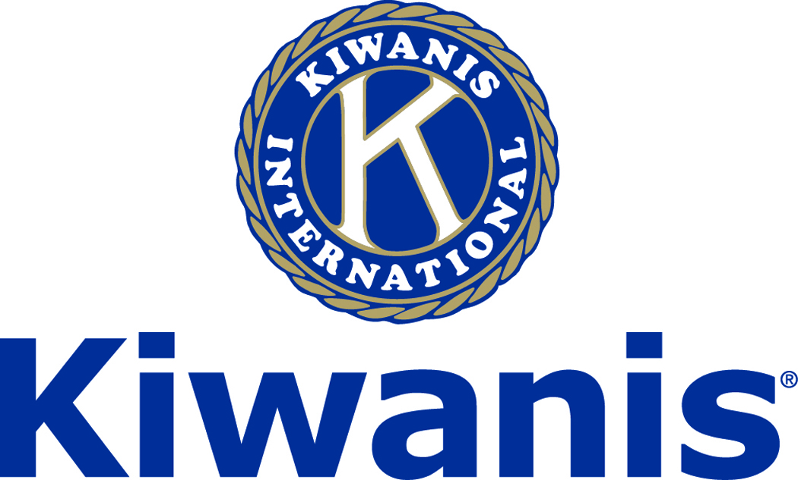

**Club of Las Vegas**

**Week of:**

**December 3, 2017**

[**http://www.kiwaniscluboflasvegas.org/**](http://www.kiwaniscluboflasvegas.org/)

**\*\*\*\*\*\*\*\*\*\*\*\*\*\*\*\*\*\*\*\*\*\*\*\*\*\*\*\*\*\*\*\*\*\*\*\*\*\*\*\*\*\*\*\*\*\*\*\*\*\*\*\*\*\*\*\*\*\*\*\*\*\*\*\*\*\***

**KIWANIS CLUB OF LAS VEGAS**

**E-Mail Silent Auction**

**Win tickets for “*The Nutcracker”***

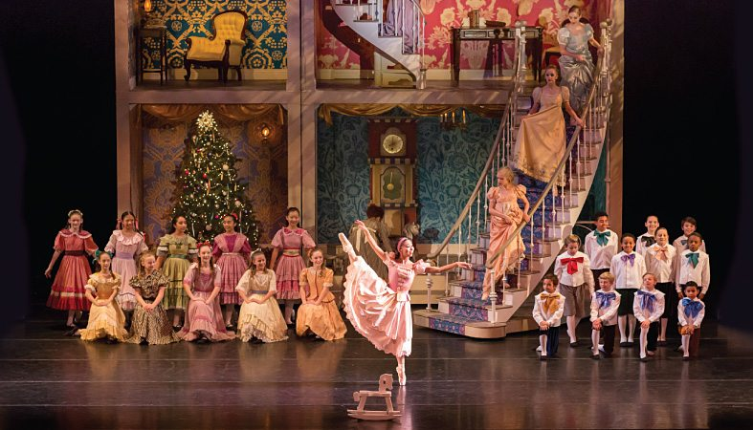

Choreographed by James Canfield, NBT’s *The Nutcracker* fills the stage with glittering holiday cheer as Tchaikovsky’s beloved score fills the theater. This magical tour through the wonder and sparkle of the season features a cast of nearly 100 dancers including NBT’s talented Company Artists and students from NBT’s affiliated Academy.

**Plan to treat your family and friends to a larger than life world filled with waltzing flowers, nimble fairies, and moonlit snow.**

**Be the high-bidder and enjoy *The Nutcracker.***

**This is an e-mail silent auction**

**Just reply to this e-mail with your bid!**

**Two tickets ($166+ value) could be yours!**

**December 17, 2017 - 2:00PM**

**Orchestra right Row: G Seats 301 & 302**

**To see the current “high-bid” log onto:**

[**www.kiwaniscluboflasvegas.org**](http://www.kiwaniscluboflasvegas.org)

**The Kiwanis Club of Las Vegas foundation has received two tickets**

**($166+ value) for the December 17th Smith Center Musical**

**“*The Nutcracker*”**

**These tickets will be awarded to the person making largest donation**

**to the Kiwanis Club of Las Vegas Foundation**

**Winning bid will be announced**

**Wednesday December 13th, 2017**

***Current high-bid: $27***

**Donation to the Kiwanis Club of Las Vegas Foundation**

**Tickets donated by a member of Kiwanis Club of Las Vegas**

******************************************************************

**SPEAKER for December 6th MEETING:**

**Lt. Governor Marianne Murphy**

**This is the Official visit from our Lt. Governor Marianne Murphy**

**Networking: 11:45am. Meeting: 12:15 to 1:15pm.**

**Wednesday’s, Marie Callender's, 8175 West Sahara,**

**Lunch ($20) and includes a slice of pie.**

******************************************************************

***Win a free lunch!***

***Read this newsletter for details***

******************************************************************

**Plan to attend!**

**This Saturday December 9th Kiwanis Club of Las Vegas**

**Pot-luck Holiday Celebration**



**When:** Saturday December 9, 2017 at 6:PM

**Where:** President John’s House at 9001 Villa Ridge Drive, Las Vegas, 89134

**Directions** for Getting to President John’s House Traveling West on Lake Mead:

Right Turn onto Del Webb Boulevard Entering Sun City Summerlin

Turn Left on Crown Ridge (3rd Stop Sign)

Turn Right on Villa Ridge Drive (1st Stop Sign 5th House on the Right)

**Beverages** including beer and wine will be provided.

**RSVP** at this weks meeting or call President John. (702) 480-1652

**Bring** a Dish to Share with Your Fellow Kiwanians.

******************************************************************

**Varsity Quiz Question of the Week**

**Do you know the answer to this question?**

***What is the term for skilled craftsmen who create functional or decorative products such as jewelry, furniture, clothing, wood carving, quilts and baskets ?***

**(the answer will be in next week’s newsletter)**

**Answer to last week’s Question**

***Which province is home to the greatest number of Canadians?***

**“*Ontario*”**

******************************************************************

**Service Hours**

**Be sure to turn in your service hours to Nancy Sapling**

**Fill out the form at our weekly lunches or**

**Email your service hours to Nancy at:** [**Nancy.Sapling7@gmail.com**](mailto:Nancy.Sapling7@gmail.com)

******************************************************************

**Varsity Quiz**

This is the seventh week of the 49th season of Varsity Quiz and the last week for most schools in division competition. The Varsity Quiz Program is patterned after a high school program that was being sponsored by the Kiwanis Club of Greater Anaheim. In 1969 a delegation from that club convinced the leadership of the Kiwanis Club of Las Vegas to sponsor a similar program in Clark County.  The Southern Nevada program was named Varsity Quiz. It is conducted within the Clark County School District (CCSD).  The Varsity Quiz Program is a partnership between the Kiwanis Club of Las Vegas, CCSD, and Vegas PBS TV-10.

******************************************************************

**Donate to the**

***Kiwanis Club of Las Vegas Foundation***

**a 501(c)(3) charitable organization**

**Help us fund our programs with your tax deductible donation to our Kiwanis Club of Las Vegas Foundation**

******************************************************************

***Please Use Amazon-Smile***

**and selecting Kiwanis Club of Las Vegas Foundation as your charity when you make your holiday purchases.**

**When you order at Amazon-Smile, Amazon donates to**

**Kiwanis Club of Las Vegas Foundation**

**To date this year we’ve received $157.57**

**Use** [**smile.amazon.com**](https://smile.amazon.com/gp/r.html?C=7HYU8Y4EZWZW&R=2OM74E2TQH61W&T=C&U=http%3A%2F%2Fsmile.amazon.com%2Fgp%2Fcharity%2Fhomepage.html%3Forig%3D%252Fgp%252Fbrowse.html%253Fnode%253D502659011%26ein%3D86-0850741%26ref_%3Dpe_732550_190307700&A=I1HQ1LDYEOQFBAICG0TGN2IDZUOA&H=SYAUSO4VGWQXCXS3JTTAWZAJXWKA&ref_=pe_732550_190307700) and Amazon will donate to Kiwanis Club of Las Vegas Foundation. Sign up with Amazon Smile and designate the Kiwanis Club of Las Vegas Foundation as your charity. Amazon will donate 0.5% of the price of your eligible Amazon Smile purchases to Kiwanis Club of Las Vegas Foundation whenever you shop on Amazon Smile. Amazon Smile is the same Amazon you know. **Same products, Same prices, Same service**. Use the link below and you will be directed to great gift ideas and help support your Kiwanis Club of Las Vegas Foundation.  
  
**AmazonSmile click here:** [**smile.amazon.com/ch/86-0850741**](https://smile.amazon.com/gp/r.html?C=2AU9G2CMQ9IQM&R=2OM74E2TQH61W&T=C&U=http%3A%2F%2Fsmile.amazon.com%2Fch%2F86-0850741&A=6PNWEYXALJ7J4QHW7SL1FV6DH3KA&H=HK0LAEKSGAKLH10PCQ1PHTOGAMEA)

******************************************************************

**UPCOMING December 2017 EVENTS**

**December 6:** - Lt. Governor Marianne Murphy for her Official visit.

**December 13:** - John Case  The Roots/cause/analysis of the Crandall coal mine disaster

**December 20:** - Dark

**December 27:** - Dark

**January 3:** - Brian Hoeft, Director of the RTC Traffic Management Center.

*******************************************************************

FREE LUNCH!

**Each week we hold a random drawing**

**and one of our members wins a free lunch, including a slice of pie, redeemable at one of our next three regular meetings.**

***Congratulations’***

**>>>> Mark Segal <<<<**

***You won a FREE Lunch***

**Redeem your free lunch at one of our next three meetings**

**Dec 6th, 13th or Jan 3rd meeting!**

*******************************************************************

**For club information Log onto our Web Site!**

[**http://www.kiwaniscluboflasvegas.org/**](http://www.kiwaniscluboflasvegas.org/)

**contact Jerry McElroy or Howard Naylor**

**with additions or corrections**

*******************************************************************

***Save your POP-TABS to benefit***

***Ronald Mc Donald House***

***If you have pop tabs to donate contact Len Yelinek.***

******************************************************************