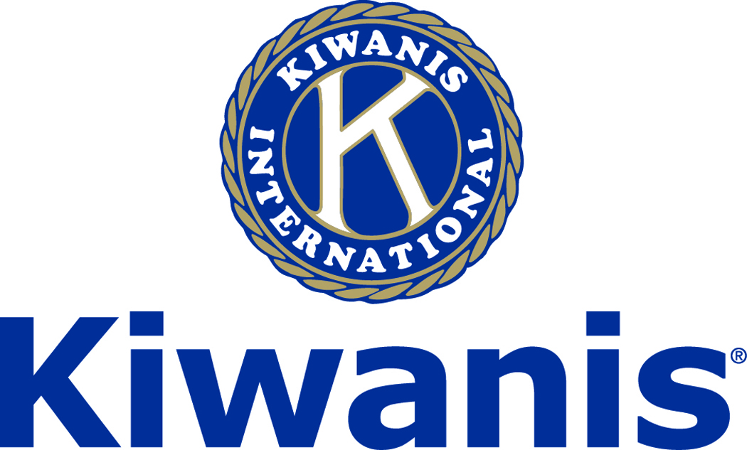
Club of Las Vegas
Week of:
August 6, 2017

http://www.kiwaniscluboflasvegas.org/

******************************************************************

Win a free lunch!
Read this newsletter for details

******************************************************************

SPEAKER for August 9 MEETING:
John A. Tsarpalas

John will speak about the Nevada Policy Research.

Networking: 11:45am. Meeting: 12:15 to 1:15pm.

Wednesday’s, Marie Callender's, 8175 West Sahara,
Lunch ($20) and includes a slice of pie.

******************************************************************

Tickets now available for.
Division 28 Lt Governor’s Installation
September 17, 2017 ~ 1 P.M. Lunch
At Revere Golf and Country Club
2600 Hampton Rd.
Henderson, Nevada
Tickets $35 cash

******************************************************************

Sign up now for the:
The Special Olympics Bowling Event
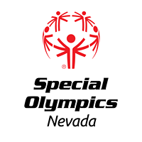

The Special Olympics Bowling event will be on August 31, at the Texas Station from 6 to 9 pm
Donation $50 per player

******************************************************************

Service Hours
Be sure to turn in your service hours to Nancy Sapling
Fill out the form at our weekly lunches or
Email your service hours to Nancy at: Nancy.Sapling7@gmail.com

******************************************************************

FREE LUNCH!

Each week we hold a random drawing
and one of our members wins a free lunch, including a slice of pie, redeemable at one of our next three regular meetings.

Congratulations’
>>>> Bill Scheer <<<<
You won a FREE Lunch

Redeem your free lunch at one of our next three meetings
Aug. 9th, 16th or 23rd meeting!
See you there!

******************************************************************

Donate to the
Kiwanis Club of Las Vegas Foundation

Help us fund our programs with your tax deductible donation to our Kiwanis Club of Las Vegas Foundation

******************************************************************

UPCOMING August 2017 EVENTS:

August 9: - John A. Tsarpalas of the Nevada Policy Research Institute

August 16: - William H. Yarroll III, Founder & Executive Director of GotKidsCharity

August 23: - TD Barnes The Latest about Area 51

August 30: - Darrellyn Bonstell About the BBB

*******************************************************************

Use Amazon-Smile for your purchases.

When you do Amazon donates to
Kiwanis Club of Las Vegas Foundation

Please Use smile.amazon.com and Amazon will donate to Kiwanis Club of Las Vegas Foundation. Sign up with Amazon Smile and designate the Kiwanis Club of Las Vegas Foundation as your charity. Amazon will donate 0.5% of the price of your eligible Amazon Smile purchases to Kiwanis Club of Las Vegas Foundation whenever you shop on Amazon Smile. Amazon Smile is the same Amazon you know. Same products, Same prices, Same service. Use the link below and you will be directed to great gift ideas and help support your Kiwanis Club of Las Vegas Foundation.
AmazonSmile click here: smile.amazon.com/ch/86-0850741

*******************************************************************

For club information Log onto our Web Site!
http://www.kiwaniscluboflasvegas.org/

contact Jerry McElroy or Howard Naylor
with additions or corrections

*******************************************************************

