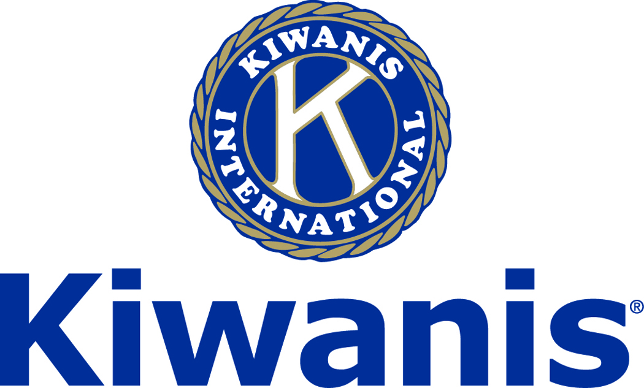
Club of Las Vegas

Week of:
July 22, 2018

http://www.kiwaniscluboflasvegas.org/

******************************************************************

SPEAKER for August 1st MEETING:

Dr. Gary Presswood
"The Accident Expert"
Networking: 11:45am. Meeting: 12:15 to 1:15pm.

Wednesday’s, Marie Callender's, 8175 West Sahara,
Lunch ($20) and includes a slice of pie.

******************************************************************

Service Hours
Be sure to turn in your service hours to Nancy Sapling

Fill out the form at our weekly lunches or
Email your service hours to Nancy at: Nancy.Sapling7@gmail.com

******************************************************************

LAST WEEK!
Dean Barbara Atkinson
Spoke about the UNLV School of Medicine

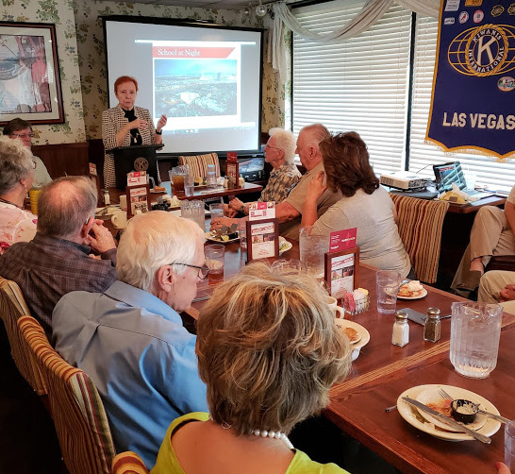

******************************************************************

Save your POP-TABS to benefit
Ronald Mc Donald House

If you have pop tabs to donate contact Len Yelinek.

******************************************************************

Please Use Amazon-Smile
Select Kiwanis Club of Las Vegas Foundation as your charity when making your purchases.

Use smile.amazon.com and Amazon will donate to Kiwanis Club of Las Vegas Foundation. Sign up with Amazon Smile and designate the Kiwanis Club of Las Vegas Foundation as your charity. Amazon will donate 0.5% of the price of your eligible Amazon Smile purchases to Kiwanis Club of Las Vegas Foundation whenever you shop on Amazon Smile. Amazon Smile is the same Amazon you know. Same products, Same prices, Same service. Use the link below and you will be directed to great gift ideas and help support your Kiwanis Club of Las Vegas Foundation.

When you order at Amazon-Smile, Amazon donates to
Kiwanis Club of Las Vegas Foundation
This year we’ve received $184.33
AmazonSmile click here: smile.amazon.com/ch/86-0850741

******************************************************************

Win a free lunch!
Read this newsletter for details

******************************************************************

Donate to the
Kiwanis Club of Las Vegas Foundation
a 501(c)(3) charitable organization

Help us fund our programs with your tax deductible donation to our Kiwanis Club of Las Vegas Foundation

******************************************************************

FREE LUNCH!

Each week we hold a random drawing
and one of our members wins a free lunch, including a slice of pie, redeemable at one of our next three regular meetings.

Congratulations’
>>>> Lee Ziegler <<<<
You won a FREE Lunch

Redeem your free lunch at one of our next three meetings
Aug 1st, 8th or 15th meeting!

*******************************************************************

UPCOMING August 2018 EVENTS

August 1: - Dr. Gary Presswood, "The Accident Expert"
August 8: - Jill Branson, A business networking consultant
August 15: -- Dan Schwarz, Bringing Cristo Rey College Prep High School to Southern NV in 2019
August 22: - Stan Nudelman, Protectors of Tule Springs
August 29: - Rae Lathrop, Manager RTC Planning:
Southern Nevada Strong - Our Regional Vision

*******************************************************************
For club information Log onto our Web Site!

You can make a donation to our club on our web home page.

http://www.kiwaniscluboflasvegas.org/

contact Jerry McElroy or Howard Naylor
with additions or corrections

******************************************************************

